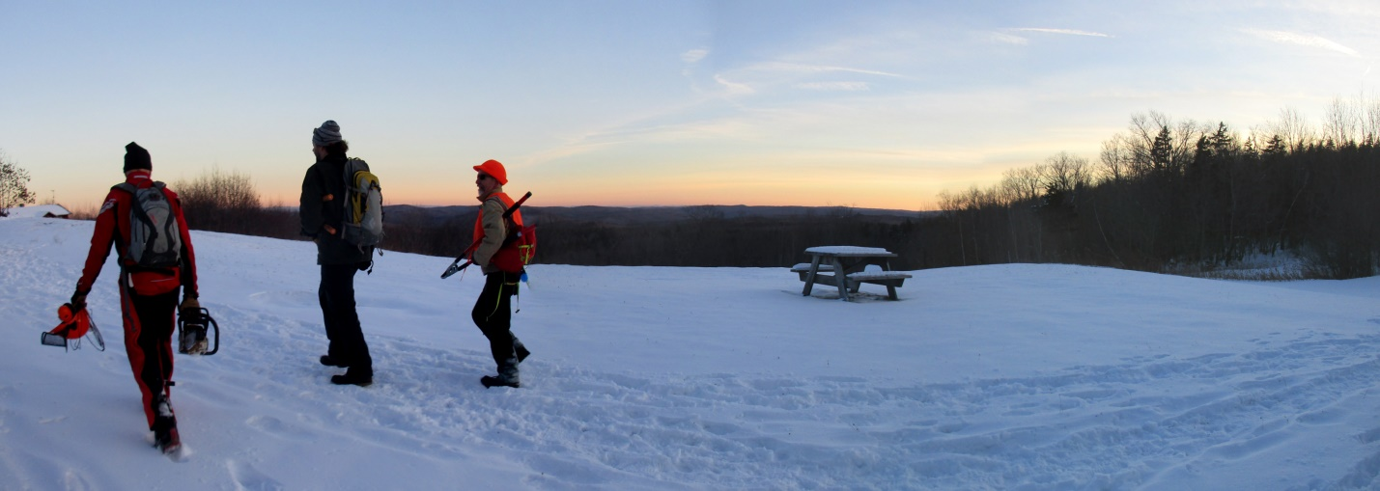

BC SKIERS HOGBACK SKI TRAIL CLEANUP THE FRIDAY AFTER T-DAY NOV 24, 1:00 pm

Join us for the traditional ski trail cleanup day at the Hogback Mountain Conservation Area the Friday after Thanksgiving. That’s Nov 24 this year. We’ll meet at 1:00 in the parking lot between the distillery and the gift shop on Route 100 in Marlboro, at the 100-mile view, and split into teams to tackle various projects. Let us know at hmca@hogbackvt.org if you plan to join us so that we can organize enough team leaders. Please consider parking in the big lot on the north side of the highway even though we’ll be meeting and working on the south side at the defunct ski area. If you enjoy backcountry or XC skiing at Hogback, this is the day to earn your turns by helping us keep the skiable lines open.

Bring your favorite tool for this kind of work. We’ll have a few tools of various kinds available to loan out. We can use some people with brush cutters or scythes to knock back the hardhack and others with loppers or hand saws to trim back face-slapping branches that are growing into the trails. We’ll need one or two folks with chainsaws to deal with any big blowdowns we find, but keep in mind that you MUST have a full set of safety gear (chaps, safety-toe boots, ear/eye/hearing protection and a helmet) in order to use a chainsaw in the conservation area.

This will be the final weekend of rifle (deer) season, so wear something bright orange or safety yellow. It’s not unusual to have a light layer of snow on the ground for this workday. That doesn’t stop us. If it’s raining or snowing heavily, assume the event is cancelled. Otherwise, dress for the weather and come on out and get ready to ski!

